- IDENTITAS
NIM : 2403001
Nama Lengkap : Siti Sa’adah
Kelas : D3 TI 2A
Program Studi : D3 TEKNIK INFORMATIKA
Jurusan : TEKNIK INFORMATIKA

- HASIL PRAKTIKUM/ TUGAS
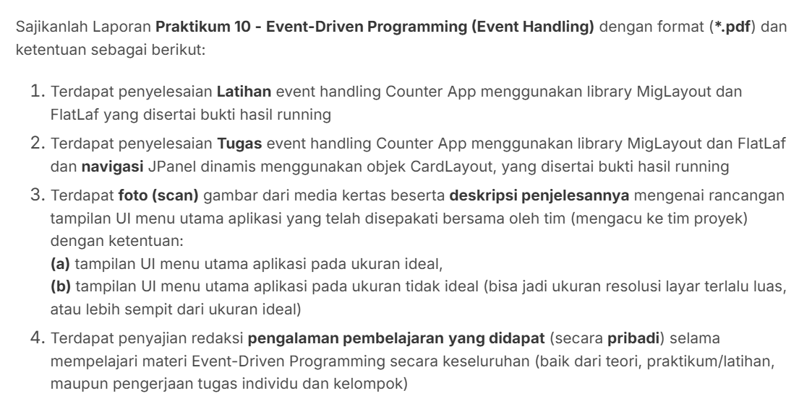
- Latihan
- Kode Program
//import java.awt.Button;
import java.awt.Dimension;
import java.awt.Font;
import javax.swing.JButton;
import javax.swing.JFrame;
import javax.swing.JLabel;
import javax.swing.JPanel;
//import javax.swing.JScrollBar;
import javax.swing.JScrollPane;
import javax.swing.SwingUtilities;
import javax.swing.UIManager;
import javax.swing.UnsupportedLookAndFeelException;
import com.formdev.flatlaf.themes.FlatMacLightLaf;
import net.miginfocom.swing.MigLayout;

public class CounterApp {
private static int nilaiCounter = 0;
public static void main(String[] args) {
try {
UIManager.setLookAndFeel(new FlatMacLightLaf());
} catch (UnsupportedLookAndFeelException e) {
e.printStackTrace();
}

SwingUtilities.invokeLater(() -> {

JFrame frame = new JFrame("Counter App Midori");
frame.setDefaultCloseOperation(JFrame.EXIT_ON_CLOSE);
frame.setPreferredSize(new Dimension(400, 300));
frame.setMinimumSize(new Dimension(200, 150));

JPanel panelCounter = new JPanel(new MigLayout("fill, wrap1", "[grow, center]", "[grow][grow]"));

JLabel labelCounter = new JLabel(nilaiCounter + "");
labelCounter.setFont(new Font("Arial", Font.BOLD, 50));
panelCounter.add(labelCounter, "bottom");

JButton buttonAdd = new JButton("+");
buttonAdd.setFont(new Font("Arial", Font.BOLD, 25));
panelCounter.add(buttonAdd, "top");

buttonAdd.addActionListener(e -> {
nilaiCounter++;
labelCounter.setText(nilaiCounter+"");
} );

JScrollPane scrollPane = new JScrollPane(panelCounter);
scrollPane.getVerticalScrollBar().setUnitIncrement(10);
scrollPane.getVerticalScrollBar().putClientProperty("JScrollBar.fastWheelScrolling", true);
scrollPane.setOpaque(true);

frame.add(scrollPane);
frame.pack();
frame.setLocationRelativeTo(null);
frame.setVisible(true);

});
}
}

- Run
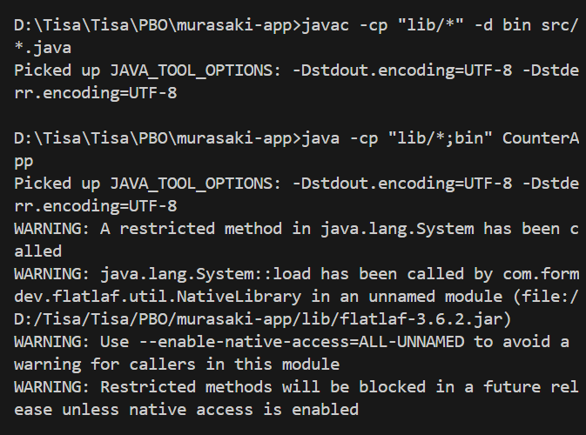

- Output
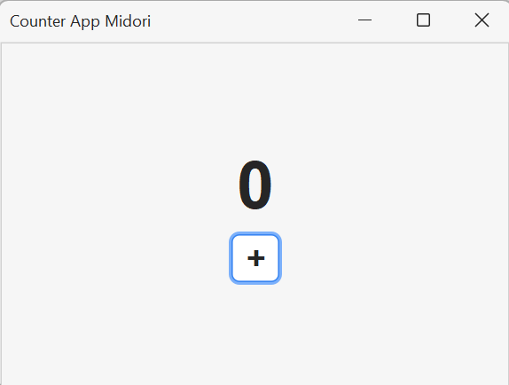

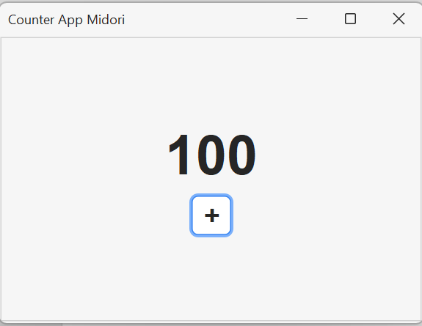

- Tugas Individu
- Percobaan 1
- Kode Program
//import java.awt.Button;
import java.awt.Dimension;
import java.awt.Font;
import javax.swing.JButton;
import javax.swing.JFrame;
import javax.swing.JLabel;
import javax.swing.JPanel;
//import javax.swing.JScrollBar;
import javax.swing.JScrollPane;
import javax.swing.SwingUtilities;
import javax.swing.UIManager;
import javax.swing.UnsupportedLookAndFeelException;
import com.formdev.flatlaf.themes.FlatMacLightLaf;
import net.miginfocom.swing.MigLayout;

public class CounterAppTugas {
private static int nilaiCounter = 0;
public static void main(String[] args) {
try {
UIManager.setLookAndFeel(new FlatMacLightLaf());
} catch (UnsupportedLookAndFeelException e) {
e.printStackTrace();
}

SwingUtilities.invokeLater(() -> {

JFrame frame = new JFrame("Counter App Midori");
frame.setDefaultCloseOperation(JFrame.EXIT_ON_CLOSE);
frame.setPreferredSize(new Dimension(400, 300));
frame.setMinimumSize(new Dimension(200, 150));

JPanel panelCounter = new JPanel(new MigLayout("fill, wrap1", "[grow, center]", "[grow][grow]"));

JLabel labelCounter = new JLabel(nilaiCounter + "");
labelCounter.setFont(new Font("Arial", Font.BOLD, 50));
panelCounter.add(labelCounter, "bottom");

JPanel panelButtons = new JPanel(new MigLayout("insets 0", "[]10[]", "[]"));

JButton buttonAdd1 = new JButton("-");
buttonAdd1.setFont(new Font("Arial", Font.BOLD, 25));
//panelCounter.add(buttonAdd1, "top");
panelButtons.add(buttonAdd1);

buttonAdd1.addActionListener(e -> {
nilaiCounter--;
labelCounter.setText(nilaiCounter+"");
} );

JButton buttonAdd = new JButton("+");
buttonAdd.setFont(new Font("Arial", Font.BOLD, 25));
//panelCounter.add(buttonAdd, "top");
panelButtons.add(buttonAdd);

buttonAdd.addActionListener(e -> {
nilaiCounter++;
labelCounter.setText(nilaiCounter+"");
} );

panelCounter.add(panelButtons, "top");

JScrollPane scrollPane = new JScrollPane(panelCounter);
scrollPane.getVerticalScrollBar().setUnitIncrement(10);
scrollPane.getVerticalScrollBar().putClientProperty("JScrollBar.fastWheelScrolling", true);
scrollPane.setOpaque(true);

frame.add(scrollPane);
frame.pack();
frame.setLocationRelativeTo(null);
frame.setVisible(true);

});
}
}

- Run
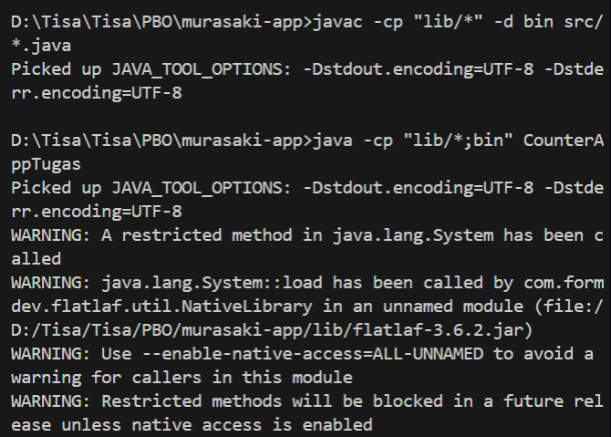

- Output
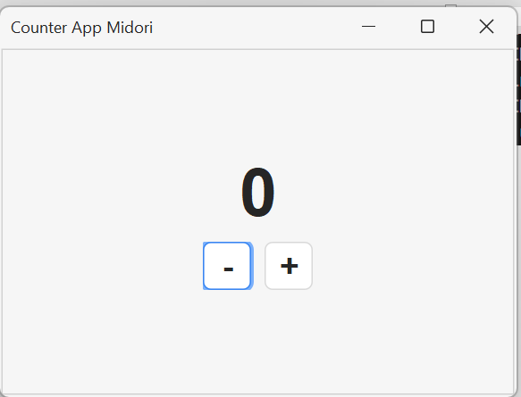

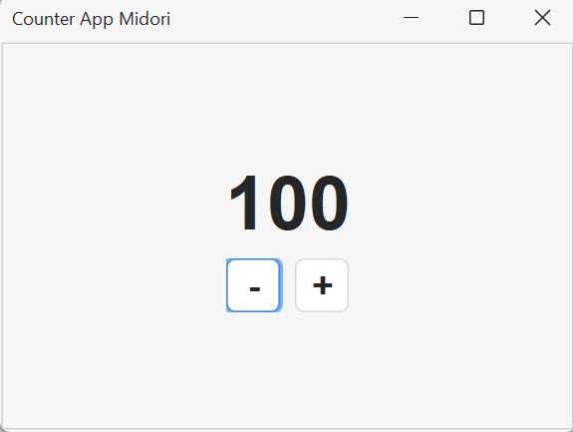
- Percobaan 2
- Kode Program
//import java.awt.Button;
import java.awt.Dimension;
import java.awt.Font;
import javax.swing.JButton;
import javax.swing.JFrame;
import javax.swing.JLabel;
import javax.swing.JPanel;
//import javax.swing.JScrollBar;
import javax.swing.JScrollPane;
import javax.swing.SwingUtilities;
import javax.swing.UIManager;
import javax.swing.UnsupportedLookAndFeelException;
import com.formdev.flatlaf.themes.FlatMacLightLaf;
import net.miginfocom.swing.MigLayout;

public class CounterAppTugas2 {
private static int nilaiCounter = 0;
public static void main(String[] args) {
try {
UIManager.setLookAndFeel(new FlatMacLightLaf());
} catch (UnsupportedLookAndFeelException e) {
e.printStackTrace();
}

SwingUtilities.invokeLater(() -> {

JFrame frame = new JFrame("Counter App Midori");
frame.setDefaultCloseOperation(JFrame.EXIT_ON_CLOSE);
frame.setPreferredSize(new Dimension(400, 300));
frame.setMinimumSize(new Dimension(200, 150));

JPanel mainPanel = new JPanel(new java.awt.CardLayout());

JPanel panelCounter = new JPanel(new MigLayout("fill, wrap1", "[grow, center]", "[grow][grow]"));

JLabel labelCounter = new JLabel(nilaiCounter + "");
labelCounter.setFont(new Font("Arial", Font.BOLD, 50));
panelCounter.add(labelCounter, "center");

JPanel panelButtons = new JPanel(new MigLayout("insets 0", "[]10[]", "[]"));

JButton buttonAdd1 = new JButton("-");
buttonAdd1.setFont(new Font("Arial", Font.BOLD, 25));
//panelCounter.add(buttonAdd1, "top");
panelButtons.add(buttonAdd1);

buttonAdd1.addActionListener(e -> {
nilaiCounter--;
labelCounter.setText(nilaiCounter+"");
} );

JButton buttonAdd = new JButton("+");
buttonAdd.setFont(new Font("Arial", Font.BOLD, 25));
//panelCounter.add(buttonAdd, "top");
panelButtons.add(buttonAdd);

buttonAdd.addActionListener(e -> {
nilaiCounter++;
labelCounter.setText(nilaiCounter+"");
} );

panelCounter.add(panelButtons, "center");

JButton buttonNext = new JButton(">");
buttonNext.setFont(new Font("Arial", Font.BOLD, 25));
panelCounter.add(buttonNext, "right, bottom");

mainPanel.add(panelCounter, "page1");

JScrollPane scrollPane = new JScrollPane(panelCounter);
scrollPane.getVerticalScrollBar().setUnitIncrement(10);
scrollPane.getVerticalScrollBar().putClientProperty("JScrollBar.fastWheelScrolling", true);
scrollPane.setOpaque(true);

frame.add(scrollPane);
frame.pack();
frame.setLocationRelativeTo(null);
frame.setVisible(true);

});
}
}

- Run
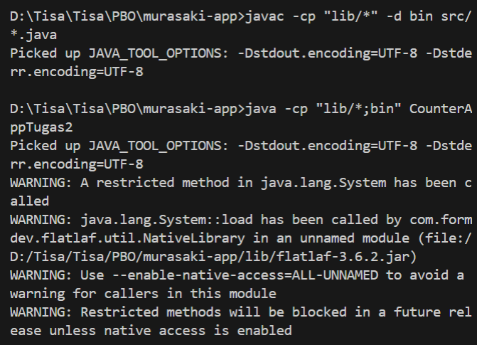

- Output
Button “>” belum berfungsi.
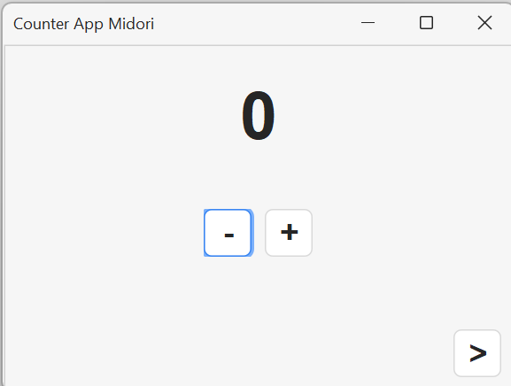

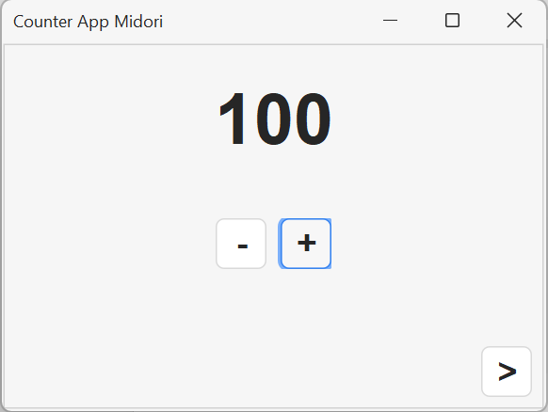
- Percobaan 3 ( Hasil Akhir)
- Kode Program
//import java.awt.Button;
import java.awt.CardLayout;
import java.awt.Dimension;
import java.awt.Font;
import javax.swing.JButton;
import javax.swing.JFrame;
import javax.swing.JLabel;
import javax.swing.JPanel;
//import javax.swing.JScrollBar;
import javax.swing.JScrollPane;
import javax.swing.SwingUtilities;
import javax.swing.UIManager;
import javax.swing.UnsupportedLookAndFeelException;
import com.formdev.flatlaf.themes.FlatMacLightLaf;
import net.miginfocom.swing.MigLayout;

public class CounterAppTugas3 {
private static int nilaiCounter = 0;
public static void main(String[] args) {
try {
UIManager.setLookAndFeel(new FlatMacLightLaf());
} catch (UnsupportedLookAndFeelException e) {
e.printStackTrace();
}

SwingUtilities.invokeLater(() -> {

JFrame frame = new JFrame("Counter App Midori");
frame.setDefaultCloseOperation(JFrame.EXIT_ON_CLOSE);
frame.setPreferredSize(new Dimension(400, 300));
frame.setMinimumSize(new Dimension(200, 150));

JPanel mainPanel = new JPanel(new CardLayout());

JPanel panelCounter = new JPanel(new MigLayout("fill, wrap1", "[grow, center]", "[grow][grow]"));

JLabel labelCounter = new JLabel(nilaiCounter + "");
labelCounter.setFont(new Font("Arial", Font.BOLD, 50));
panelCounter.add(labelCounter, "center");

JPanel panelButtons = new JPanel(new MigLayout("insets 0", "[]10[]", "[]"));

JButton buttonAdd1 = new JButton("-");
buttonAdd1.setFont(new Font("Arial", Font.BOLD, 25));
//panelCounter.add(buttonAdd1, "top");
panelButtons.add(buttonAdd1);

buttonAdd1.addActionListener(e -> {
nilaiCounter--;
labelCounter.setText(nilaiCounter+"");
} );

JButton buttonAdd = new JButton("+");
buttonAdd.setFont(new Font("Arial", Font.BOLD, 25));
//panelCounter.add(buttonAdd, "top");
panelButtons.add(buttonAdd);

buttonAdd.addActionListener(e -> {
nilaiCounter++;
labelCounter.setText(nilaiCounter+"");
} );

panelCounter.add(panelButtons, "center");

JButton buttonNext = new JButton(">");
buttonNext.setFont(new Font("Arial", Font.BOLD, 25));
panelCounter.add(buttonNext, "right, bottom");

mainPanel.add(panelCounter, "page1");

JPanel panelResult = new JPanel(new MigLayout("fill, wrap1", "[grow, center]", "[grow][grow][grow]"));

JLabel labelInfo = new JLabel("Nilai terakhir Anda adalah");
labelInfo.setFont(new Font("Arial", Font.PLAIN, 18));
panelResult.add(labelInfo, "center");

JLabel labelHasil = new JLabel("0");
labelHasil.setFont(new Font("Arial", Font.BOLD, 50));
panelResult.add(labelHasil, "center");

JButton buttonBack = new JButton("<");
buttonBack.setFont(new Font("Arial", Font.BOLD, 25));
panelResult.add(buttonBack, "left, bottom");

mainPanel.add(panelResult, "page2");

buttonNext.addActionListener(e -> {
labelHasil.setText(String.valueOf(nilaiCounter));
CardLayout cl = (CardLayout) mainPanel.getLayout();
cl.show(mainPanel, "page2");
} );

buttonBack.addActionListener(e -> {
CardLayout cl = (CardLayout) mainPanel.getLayout();
cl.show(mainPanel, "page1");
});

JScrollPane scrollPane = new JScrollPane(mainPanel);
scrollPane.getVerticalScrollBar().setUnitIncrement(10);
scrollPane.getVerticalScrollBar().putClientProperty("JScrollBar.fastWheelScrolling", true);
scrollPane.setOpaque(true);

frame.add(scrollPane);
//frame.add(mainPanel);
frame.pack();
frame.setLocationRelativeTo(null);
frame.setVisible(true);

});
}
}

- Run
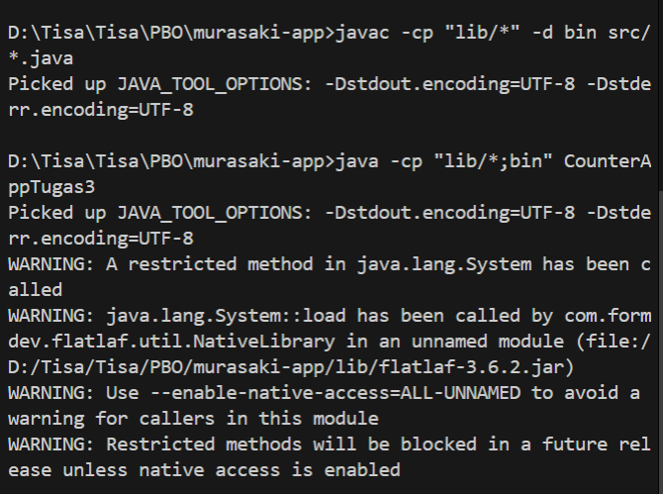

- Output
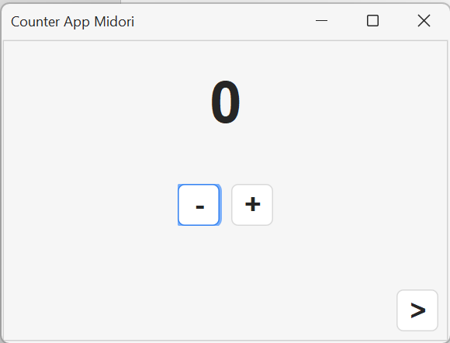

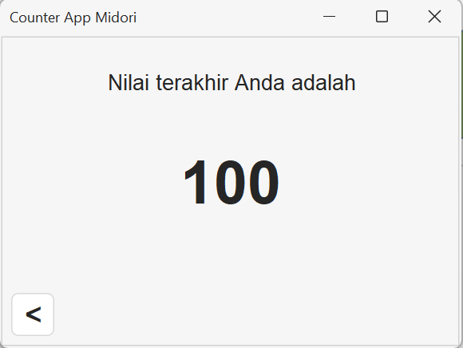
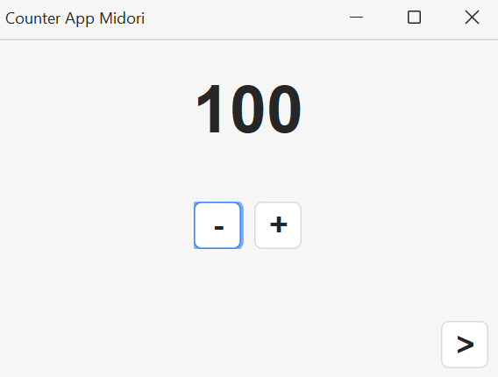
- Pengalaman Pembelajaran
Pada materi Event-Driven Programing ini kita mempelajari cara membuat perangkat lunak yang terpicu oleh event yang berbeda beda. Yaitu :
- Event Source
- Event Trigger
- Event Object
- Event Dispatching
- Event Listener
- Event Handler
Selain itu kategori Event Handling terbagi menjadi 3 :
- Semantic
- Low-level
- Specific

Masih agak sedikit bingung dalam pemakaian(praktikum) karena agak tertinggal dari materi Layered Architecture Pattern, disebabkan ada sedikit kendala berupa laptop mati dan sakit juga. Namun pada akhirnya ada yang membantu sehingga dapat mengejar agak ketertinggalan tersebut.

- Link Repository
https://github.com/Tisa-34/murasaki-app

